## SDLC-AI Enhanced Software Development Lifecycle Assistant

**1. INTRODUCTION**

**1.1 Project Overview**  
SDLC-AI is a Generative AI-powered assistant designed to help developers, students, and teams quickly create and explore Software Development Lifecycle (SDLC) documents and concepts.

**1.2 Purpose**  
To automate and simplify the generation of SDLC documents like SRS, test plans, and Agile model explanations using IBM Granite AI integrated with FastAPI and Streamlit.

**2. IDEATION PHASE**

**2.1 Problem Statement**  
Manual preparation of SDLC documentation is slow, repetitive, and often inconsistent, making it challenging for students and junior developers.

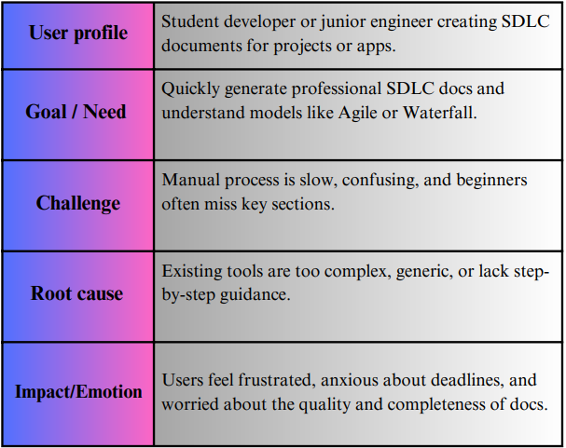

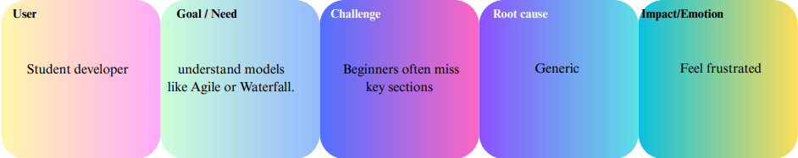

**2.2 Empathy Map Canvas**  
Focused on learners and teams who struggle to write SDLC documents efficiently.

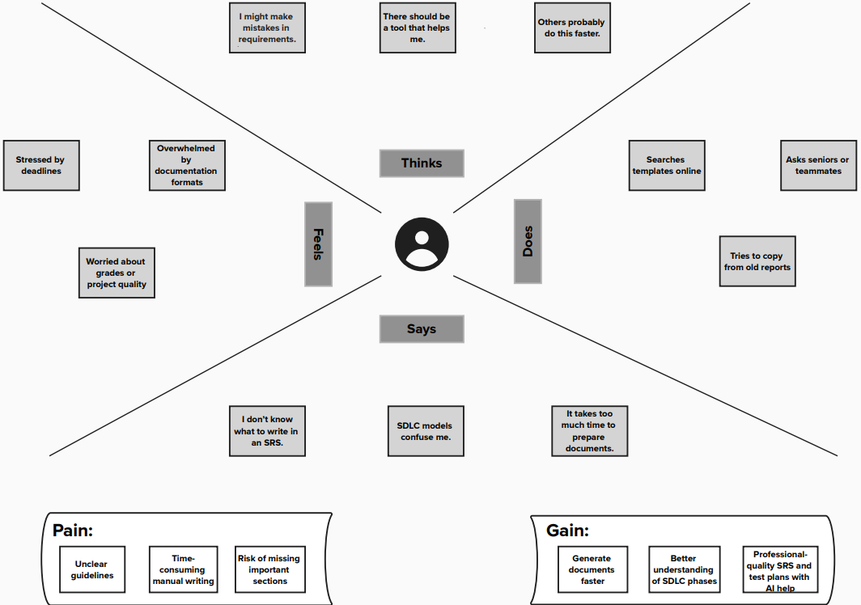

**2.3 Brainstorming**  
Leverage Generative AI to auto-create SDLC templates; integrate a clean frontend and an admin/testing interface.

**3. REQUIREMENT ANALYSIS**

**3.1 Customer Journey Map**  
User logs in → selects/sends prompt → AI generates content → user reviews/downloads → optionally uploads a document for analysis.

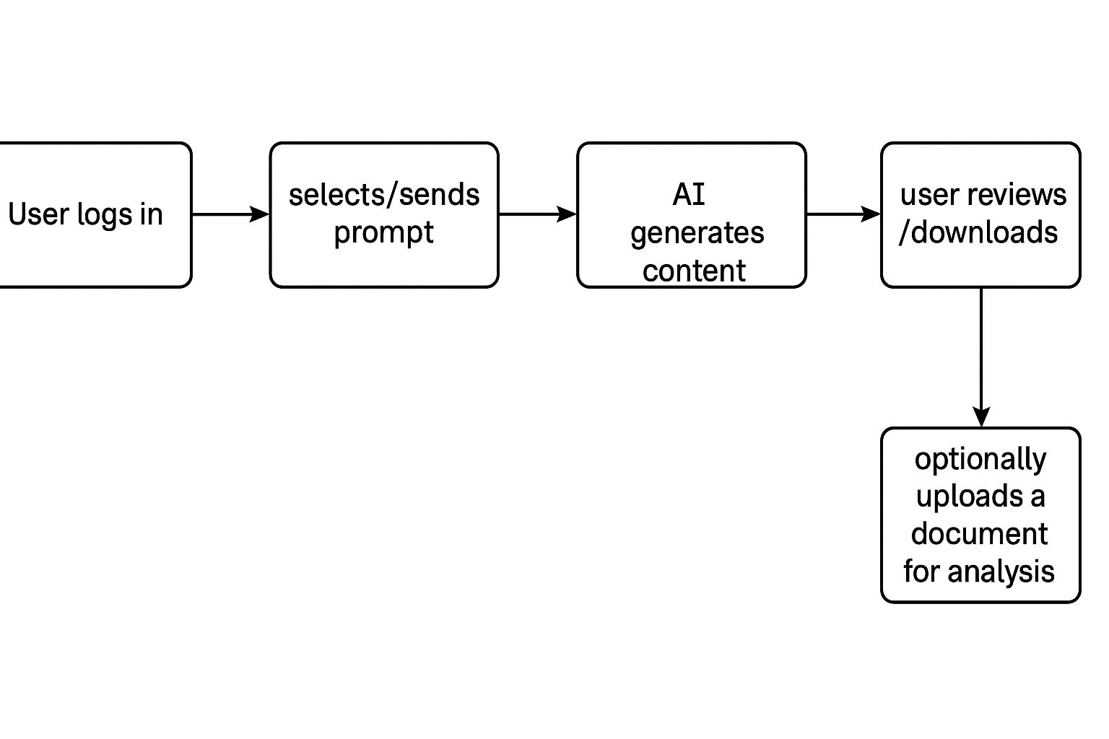

**3.2 Solution Requirements**

* Hugging Face AI model (ibm-granite/granite-3.3-2b-instruct)
* FastAPI backend
* HTML/CSS templates
* PDF export, login/signup, file upload, chat history
* Streamlit dashboard for prompt testing & admin view

**3.3 Data Flow Diagram**  
User → FastAPI → IBM Granite → AI response → display on UI → download as PDF

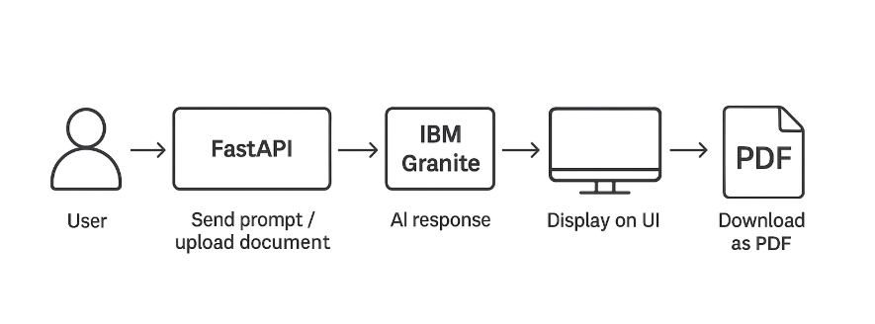

**3.4 Technology Stack**

* FastAPI (Python framework)
* Hugging Face Transformers + IBM Granite
* HTML, CSS, Jinja2
* Streamlit

**4. PROJECT DESIGN**

**4.1 Problem-Solution Fit**  
Manual SDLC writing becomes automated and faster; improves consistency.

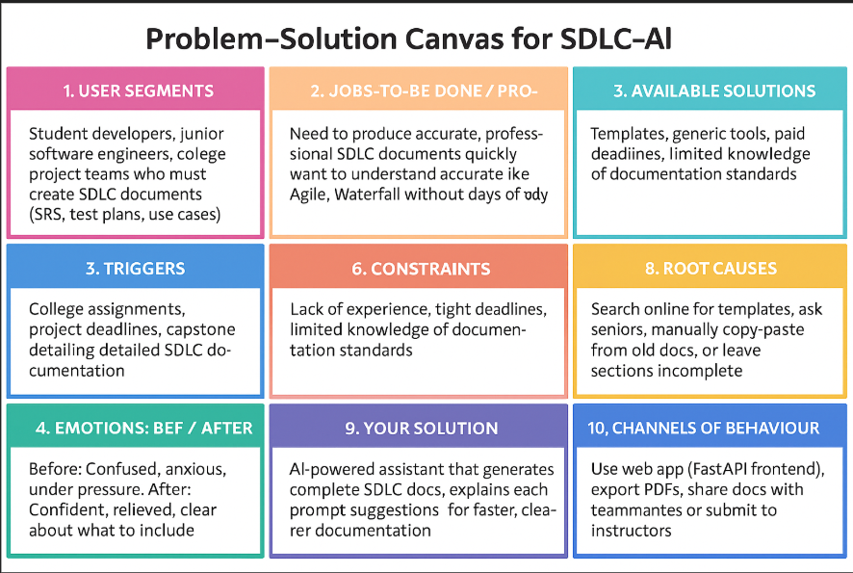

**4.2 Proposed Solution**

* Prompt suggestions as quick buttons
* Dark mode toggle
* Download as PDF
* File upload (analyze documents)
* Streamlit dashboard for admin and prompt testing

**4.3 Solution Architecture**  
User interacts via browser → FastAPI backend → IBM Granite model → returns AI-generated SDLC content.  
Parallel: Streamlit dashboard accesses same model for quick testing/admin view.

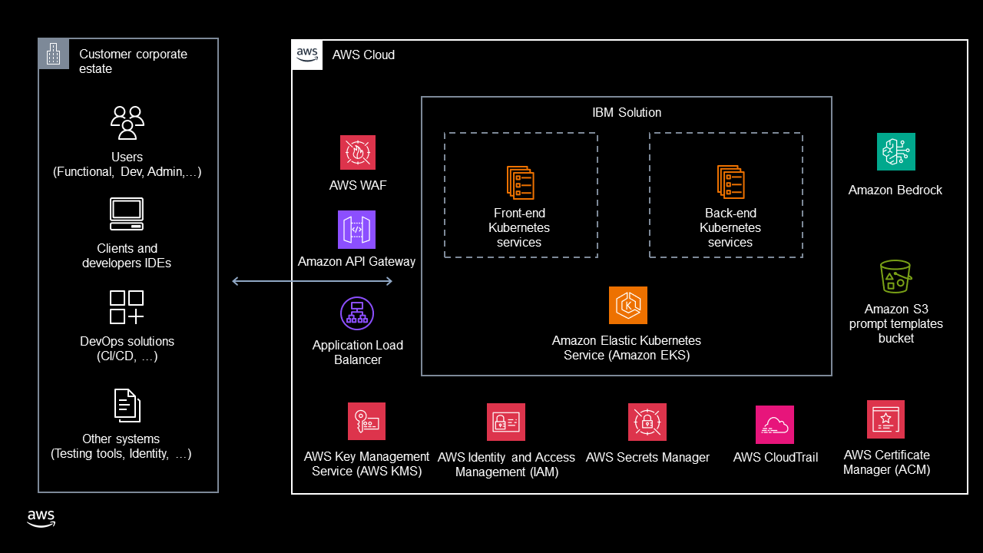

**5. PROJECT PLANNING & SCHEDULING**

* Setup FastAPI with HTML templates
* Integrate IBM Granite AI model
* Implement login, signup, and session handling
* Add prompt suggestions and PDF export
* Develop Streamlit dashboard
* Test, debug, and deploy

**6. FUNCTIONAL AND PERFORMANCE TESTING**

* Tested prompt suggestions, manual input, and file upload features.
* Monitored response times via logs.
* Validated login/signup flow and PDF export functionality.

**7. RESULTS**

**7.1 Signup.html:**

**Output**

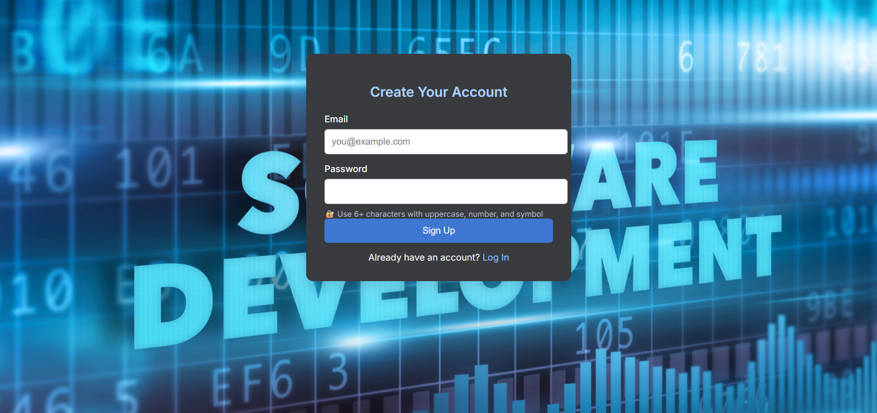

**Description:**

This view shows the sign-up page of the SDLC-AI Assistant, where new users can easily register using their email and a secure password. The interface guides users to create strong passwords by suggesting a mix of uppercase letters, numbers, and symbols, ensuring better account security. Designed with a modern background and centered form, it provides a user-friendly and professional first impression. Once registered, users can seamlessly log in to access the AI-powered SDLC tools and start generating project documentation. This simple sign-up process helps even non-technical users onboard quickly and confidently.

**7.2 Login.html:**

**Output**

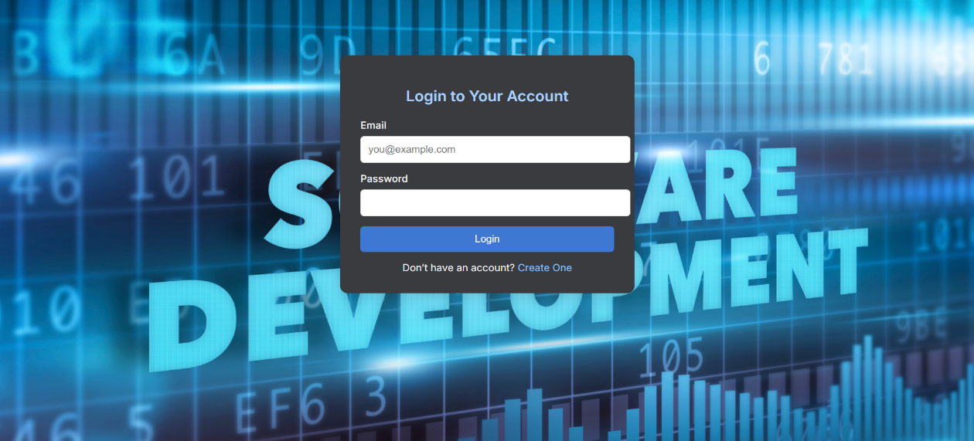

**Description:**

This login page provides a clean and user-friendly interface for users to securely access the SDLC-AI Assistant. By entering their email and password, users can quickly sign in and start working on SDLC documentation or exploring AI-powered features. The clear layout makes it easy for both new and returning users to navigate. Additionally, the option to create a new account is provided for first-time users, ensuring everyone can get started without hassle. Overall, this page is designed to make the login process straightforward, efficient, and accessible.

**7.3 Chat.html:**

**Output**

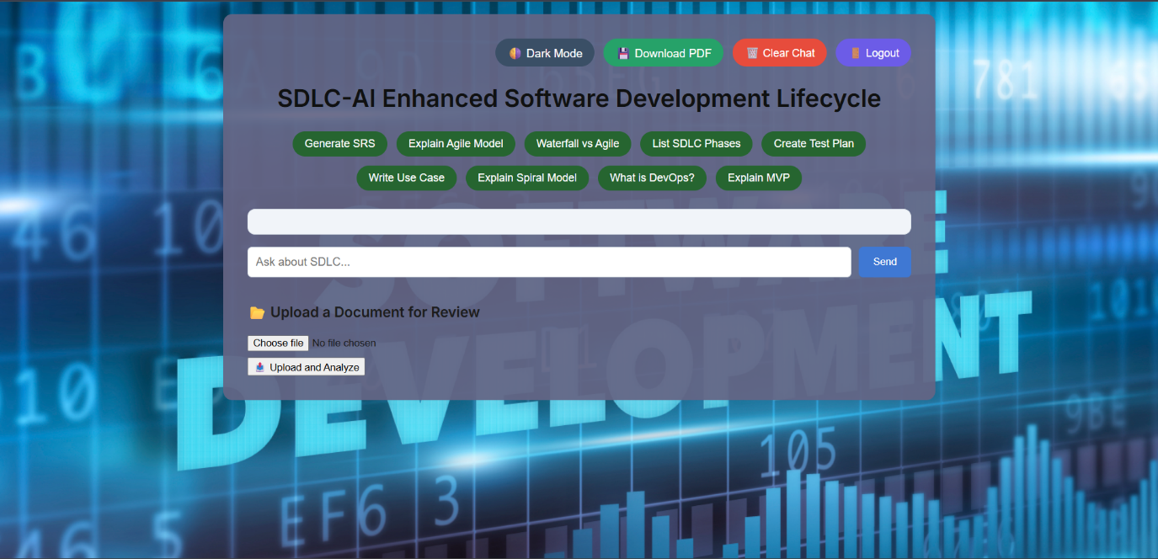

**Description:**

This main dashboard page offers users an intuitive interface to interact with the SDLC-AI Assistant. It features quick-access prompt buttons for generating common SDLC documents and explanations, making it easy to get started. The clean layout includes options to upload and analyze documents, along with tools to toggle dark mode, clear chat history, download conversations as PDF, and securely log out. Overall, it’s designed to simplify SDLC content creation and learning through an AI-powered experience.

**7.4 Main.py:**

**Output**

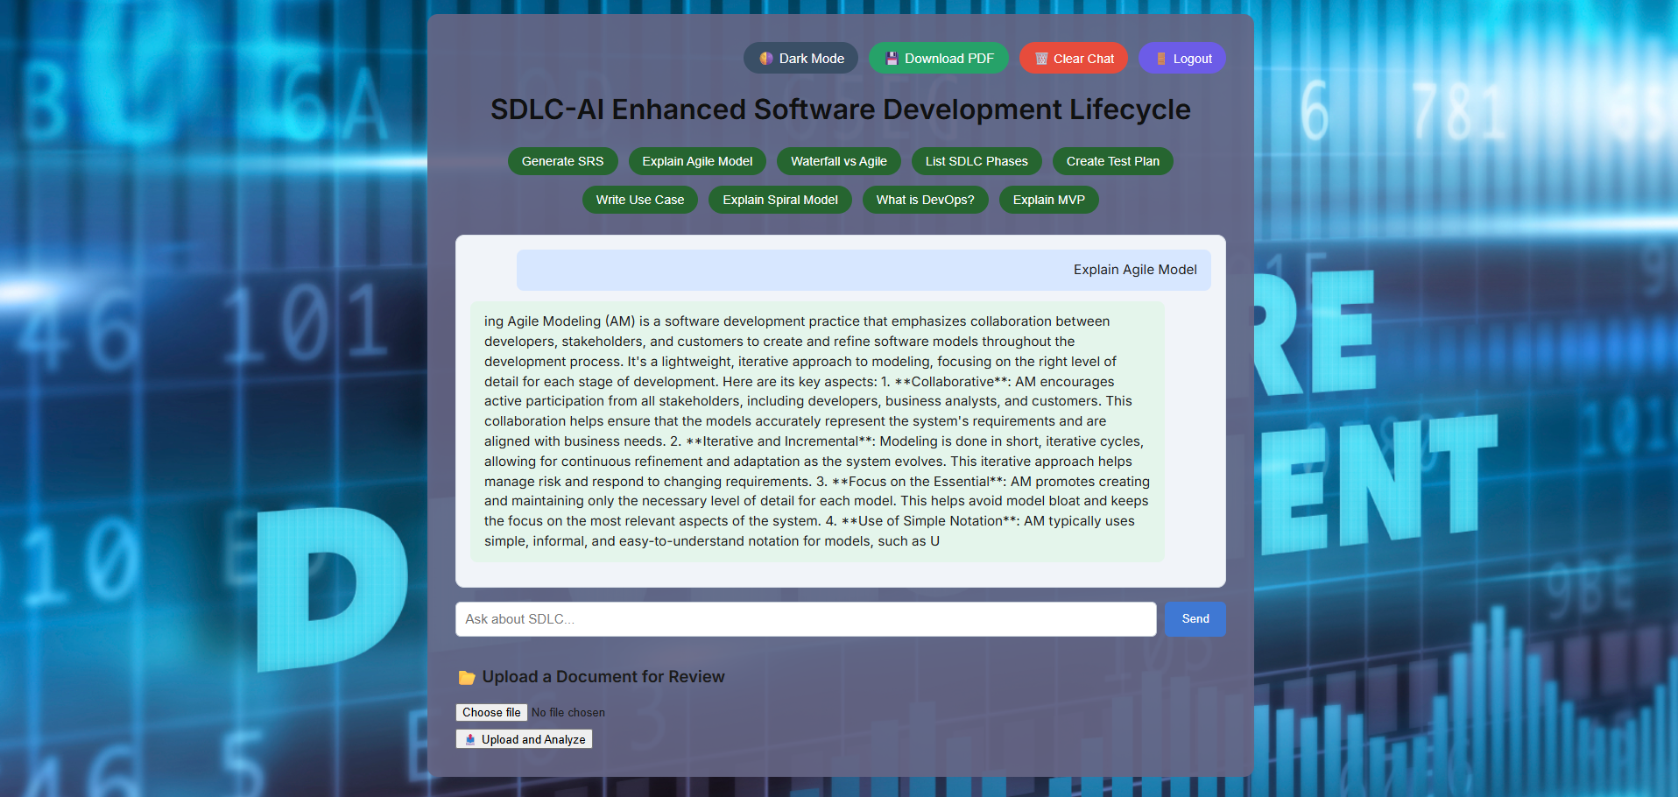

**Description**:

This view shows the SDLC-AI Assistant web interface, built on top of the main.py FastAPI backend and integrated with the IBM Granite model from Hugging Face. Users can generate rich SDLC documentation by simply clicking on prompt buttons like Explain Agile Model, Generate SRS, or List SDLC Phases. Each user input is processed on the backend, which produces detailed AI-driven responses and keeps the chat history updated seamlessly. The application also supports file upload to analyze documents and extract insights automatically. With additional features like dark mode, PDF download, and chat clearing, the platform creates an intuitive and professional environment for software engineering students and developers.

**7.5 App.py:**

**Output**

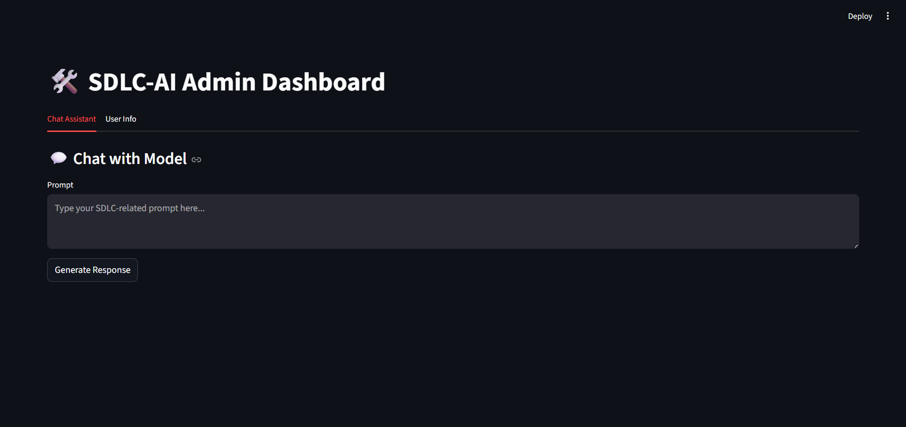

**Description:**

This admin dashboard page offers a streamlined interface to interact directly with the AI model. Designed for quick SDLC-related prompt testing and verification, it helps administrators or developers generate instant responses without navigating the main user interface. The dark-themed layout ensures readability, while the simple prompt box and response button keep the workflow clear and focused. It’s ideal for maintaining, debugging, or enhancing the system’s prompt capabilities behind the scenes.

**8. ADVANTAGES & DISADVANTAGES**

✅ Faster documentation, user-friendly, prompt suggestions, admin dashboard.  
⚠️ Relies on internet and external AI model; limited customization in generated docs.

**9. CONCLUSION**

SDLC-AI reduces manual effort and enhances SDLC learning by automatically generating high-quality documentation and explanations.

**10. FUTURE SCOPE**

* Live editor to edit AI outputs
* GitHub integration to save/export directly
* User analytics dashboard
* Advanced file upload analysis

**11. APPENDIX**

* **Source Code**: https://github.com/narra9999488/SDLC-AI-Enhanced-Software-Development-Lifecycle